Institute of Technology of Cambodia

Department of Information Technology   
and communication

Operating System

Name of students ID of students

1. Pheng Menghour e20210737

Lecturer: Mr. Heng Rathpisey

Academic Year 2024-2025

TP3

* Exercise 1
  + Go to Home directory (Your username directory)
  + cd ~
  + Create a folder named ‘CopyingFolder’, in the folder, create a text file copied.txt.
  + Now copy this file to ‘Documents’ folder.
  + In Documents folder, create 5 text file, one.txt, two.txt, ... five.txt.
  + Copy all these files to ‘CopyingFolder’.
  + Copy ‘CopyingFolder’ to Desktop.

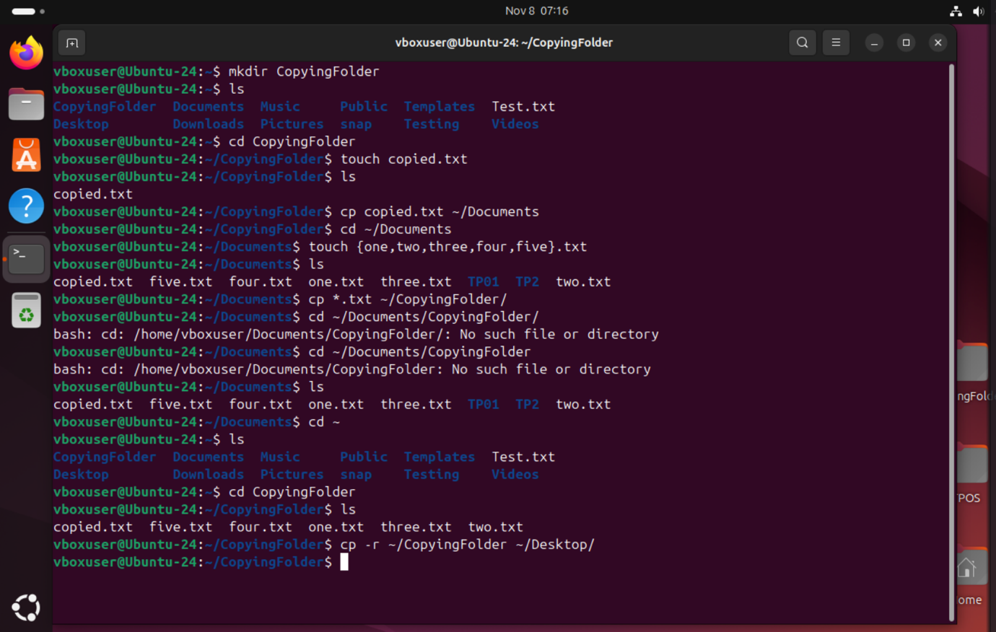

* In Documents folder, create 5 textfiles, one_document.txt, two_document.txt, three_document.txt, ..., five_document.txt
* In each file write the number correspondent, 1 in one_document.txt, etc.
* Rename each file to French words, document_un, document_deux, document_trois, document_quatre, document_cinque.txt
* Move these files to a new folder named MoveFolder
* Create a folder on Desktop named FrenchFolder
* Move all the files with just one command using * from MoveFolder to FrenchFolder.

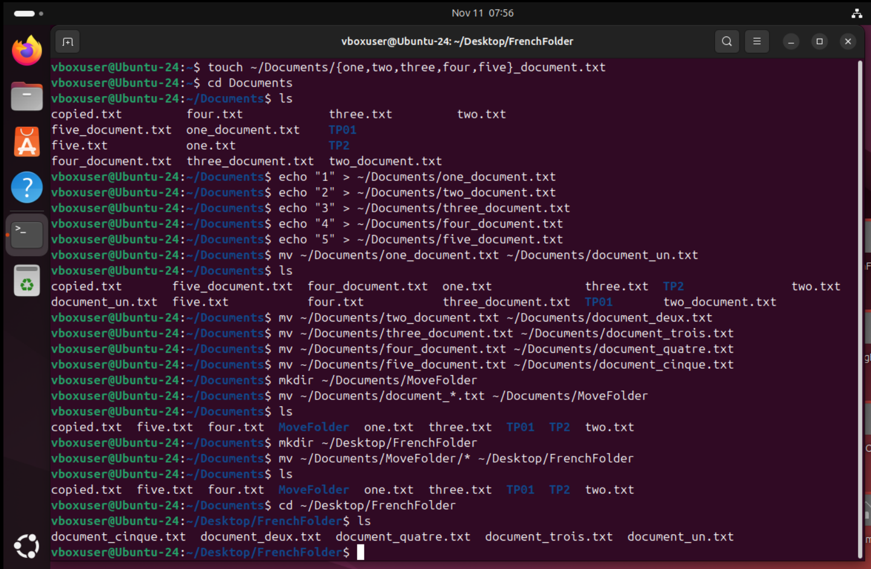

* From Home Directory, remove a file name document_deux.txt in FrenchFolder.
* Go to Documents folder and create a folder name EmptyFolder.
* In EmptyFolder, create a textfile named deletefile.txt and another folder named DeleteFolder in EmptyFolder.

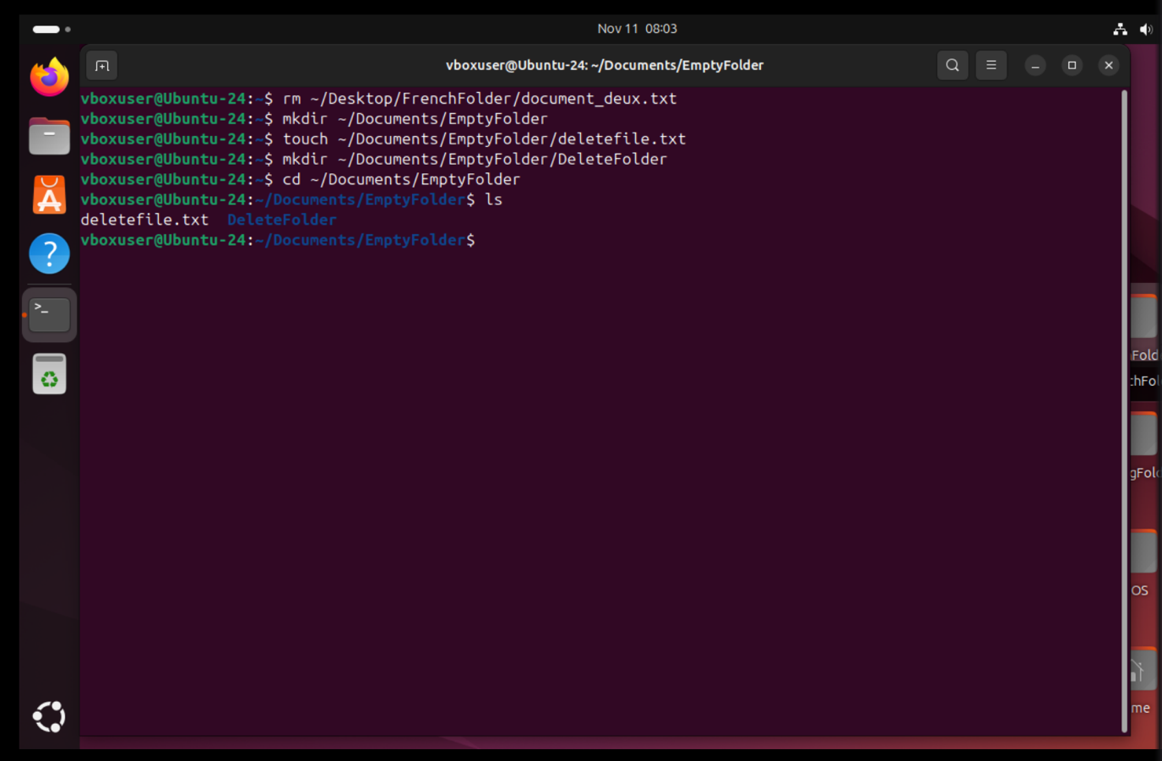

1. Command to delete DeleteFolder:

rm -r ~/Documents/EmptyFolder/DeleteFolder

1. Command to delete EmptyFolder:

rm -r ~/Documents/EmptyFolder

1. Command to delete all text file in FrenchFolder

rm -r ~/Desktop/FrenchFolder/*.txt

* Exercise 2:

1. Navigate to the Lab Directory:

* Open a terminal.
* Create a directory for this lab session, e.g., wildcard_lab.
* Navigate to the lab directory using the cd command.

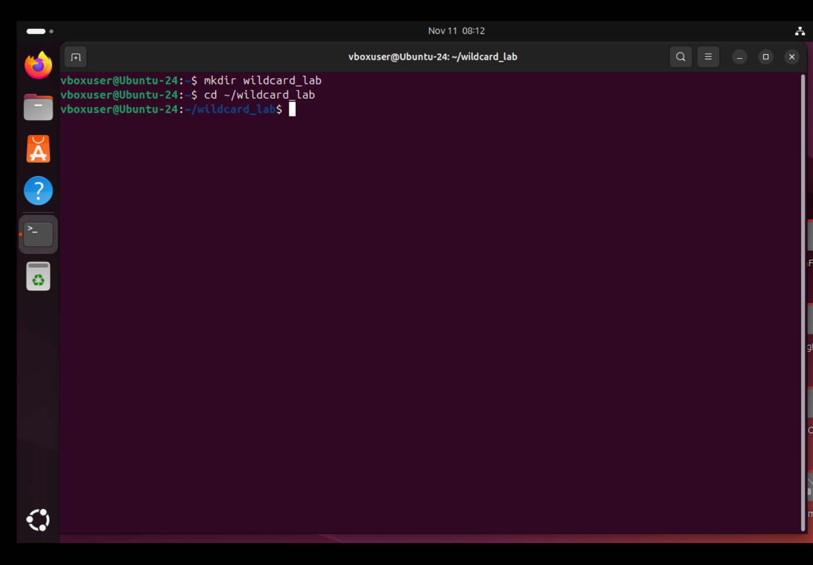

1. Create Sample Files:

* Inside the lab directory, create several sample files with different extensions (e.g., .txt, .csv, .log) using the touch command.
* Give them meaningful names.

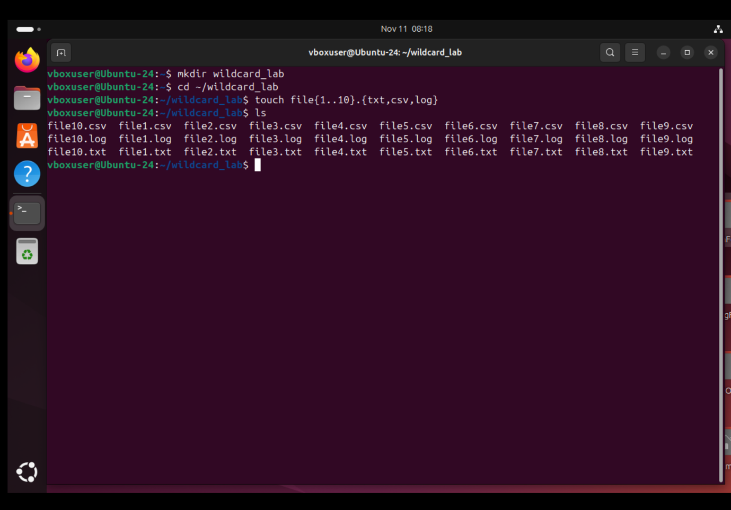

1. List Files Using Wildcards:

* Use the ls command with wildcards to list specific groups of files. Try the following:
* List all files with the .txt extension.
* List all files with the .log extension.
* List files with a single-character name.

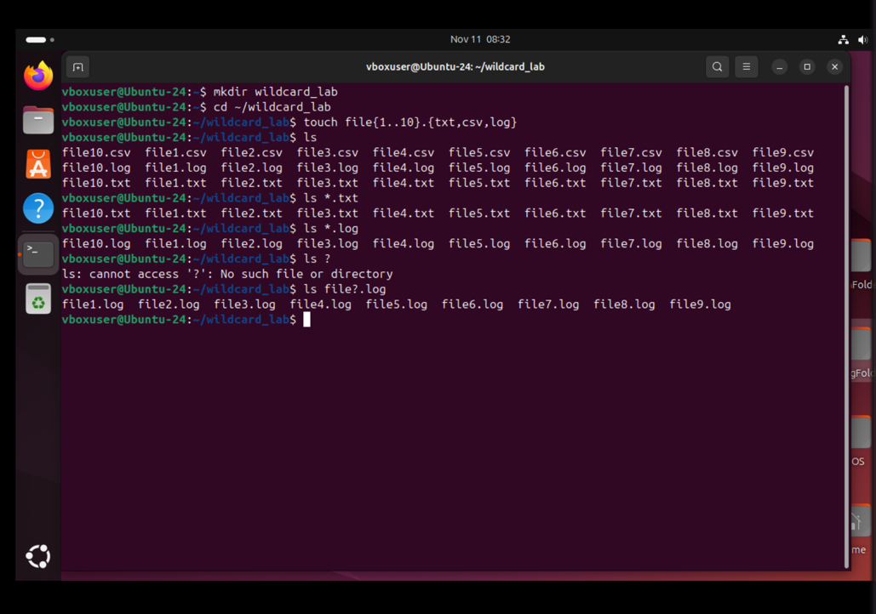

1. Copy Files Using Wildcards:

* Create a new directory within the lab directory (e.g., backup).
* Use the cp command with wildcards to copy files into the backup directory.
* Copy all .txt files into the backup directory.
* Copy files with a name of exactly three characters into the backup directory.

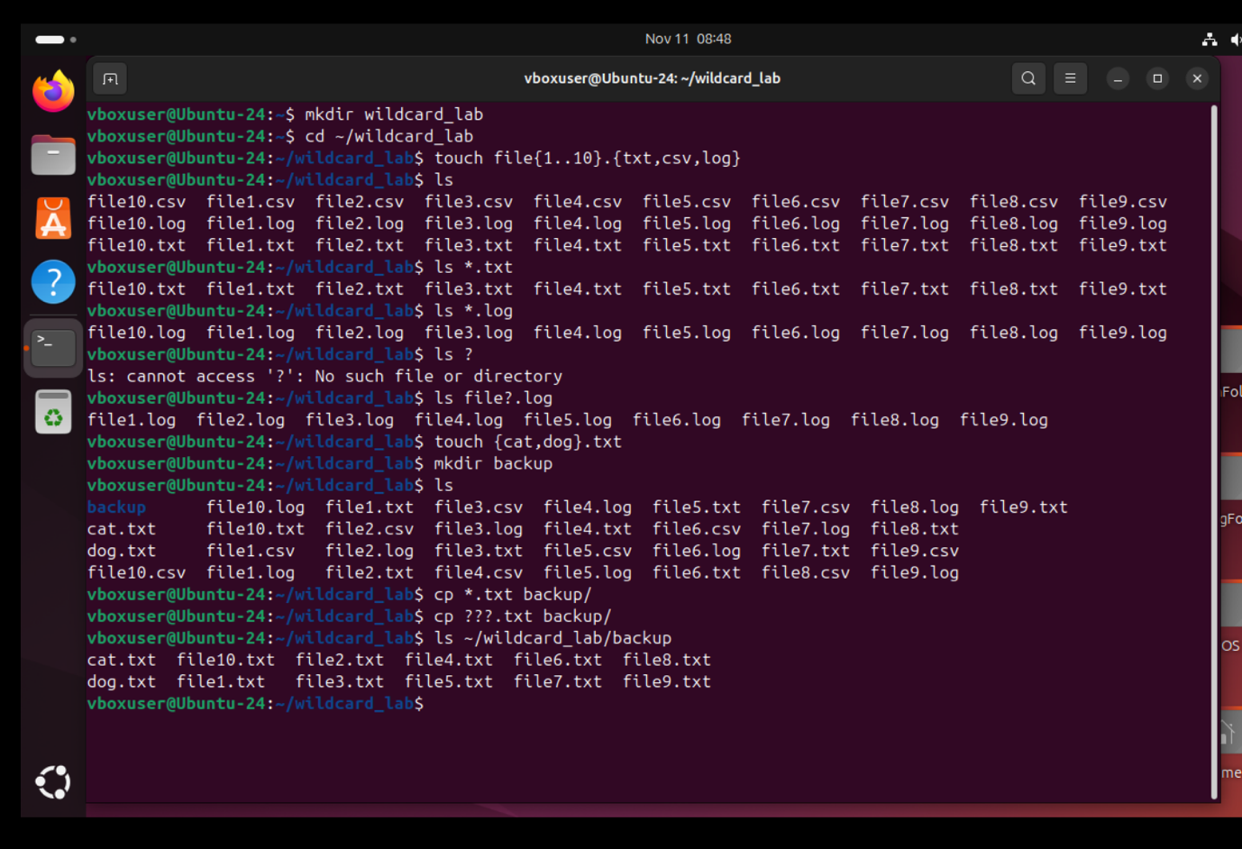

1. Deleting Files:

* Use the rm command with wildcards to delete files.
* Delete all files in the lab directory with a single-character name.
* Delete all files in the backup directory.

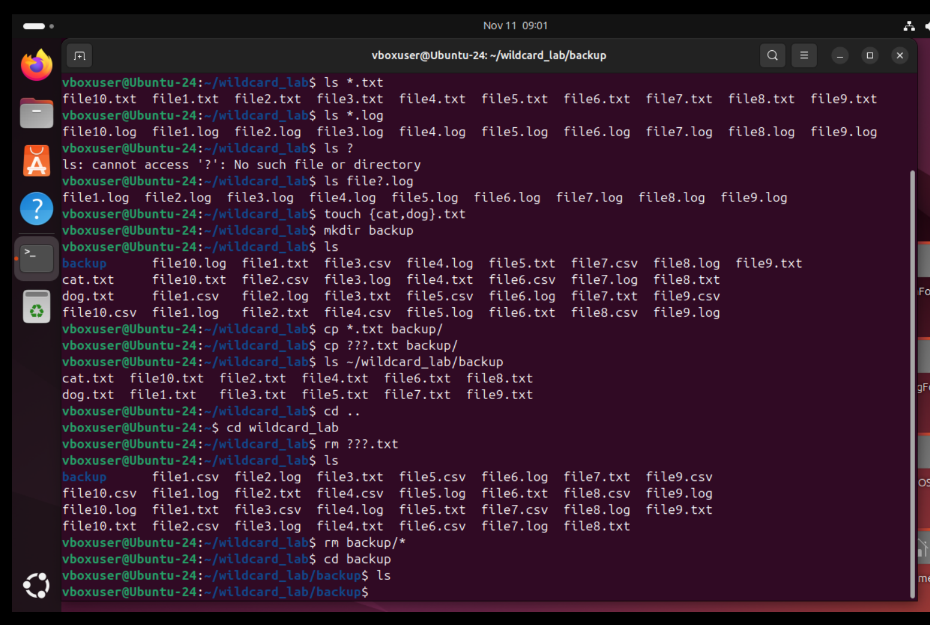

1. Advanced Wildcards:

* Create new sample files to experiment with advanced wildcards.
* Use curly braces to create files like file1.txt, file2.txt, file3.txt, etc.
* Use square brackets to list files like:  
  file1.txt, file2.txt, file3.txt, etc.

1file.txt, 2file.txt, 3file.txt, etc.

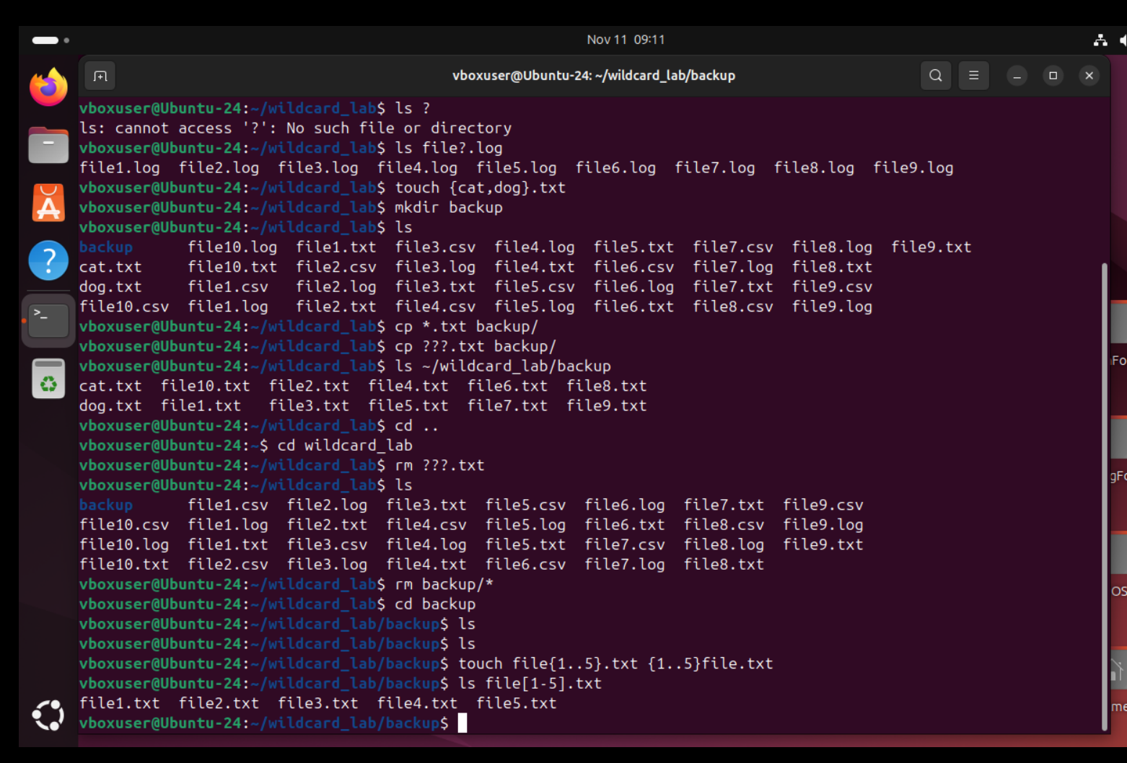

* Exercise 3:

1. Create a directory named logs in your home directory.

* Inside the logs directory, create the following log files with different timestamps in their names (e.g., log20230101.txt, log20230102.txt, etc.):

log20230101.txt

log20230102.txt

log20230103.txt

log20230104.txt

log20230105.txt

1. Use a wildcard pattern to list and display only the log files that have timestamps in January 2023 (files like log20230101.txt, log20230102.txt, etc.).
2. Use a wildcard pattern to list and display only the log files that have timestamps on days ending in an odd number (files like log20230101.txt, log20230103.txt, log20230105.txt, etc.).

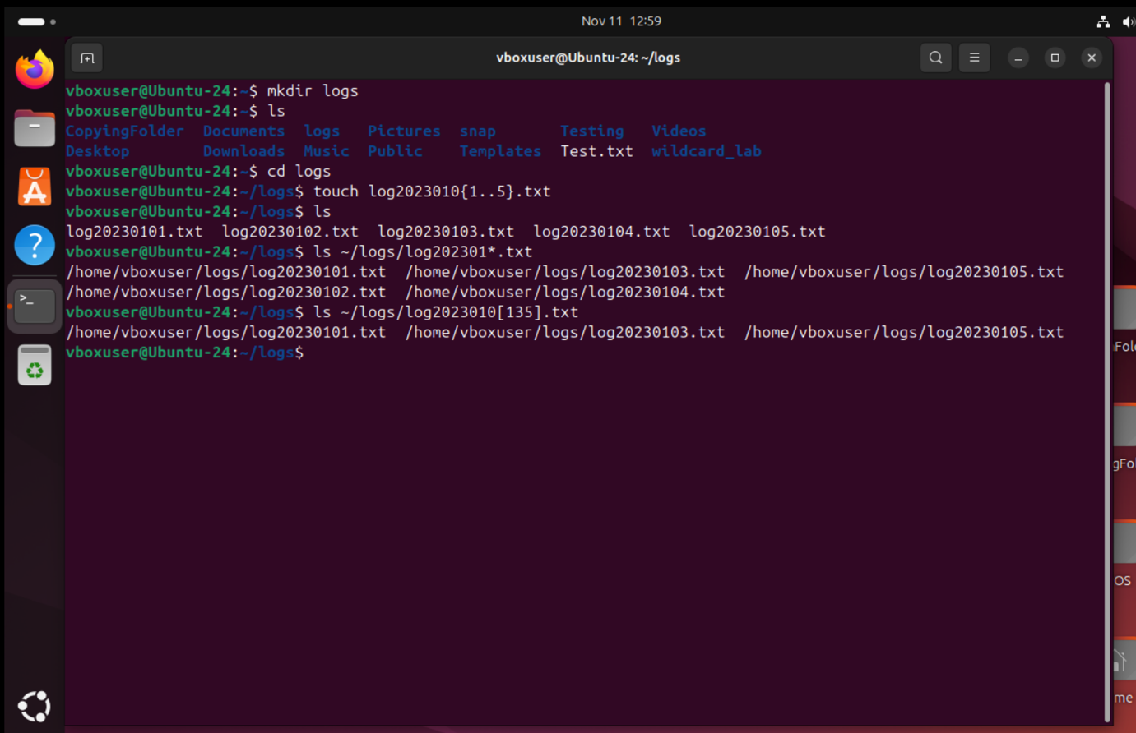

* Exercise 4
* Create a directory named **link_lab**.
* Inside **link_lab,** create a text file named **original.txt** and add some content to it.
* Create a symbolic link to **original.txt** named **symlink.txt**.
* Create a hard link to **original.txt** named **hardlink.txt**.
* Verify that changes to **original.txt** are reflected in both **symlink.txt** and **hardlink.txt**.
* Try creating a symbolic link to a non-existent file or directory.

